Vulnerability Assessment Lab #07
Title: Vulnerability Assessment of an Intentionally Vulnerable Web Application
Tools Used: Nmap, Nikto, Nessus
Target Platform: Apache HTTP Server (Local Testing Machine)

1. Objective
The objective of this lab is to design an intentionally vulnerable web application containing five OWASP Top 10 vulnerabilities, deploy it in a controlled testing environment, and perform a vulnerability assessment using industry-standard tools such as Nmap, Nikto, and Nessus. The goal is to identify security weaknesses and propose appropriate remediation measures.

2. Vulnerable Application Design
An intentionally vulnerable web application was developed using PHP and MySQL and hosted on an Apache HTTP Server. The application includes the following five OWASP Top 10 vulnerabilities:
- SQL Injection (SQLi)

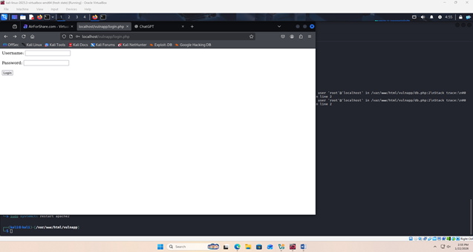
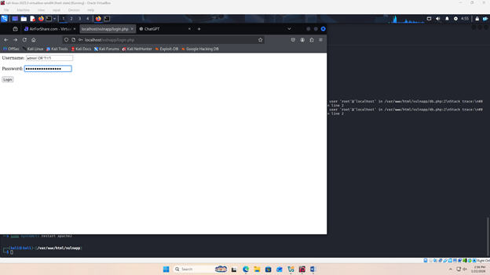
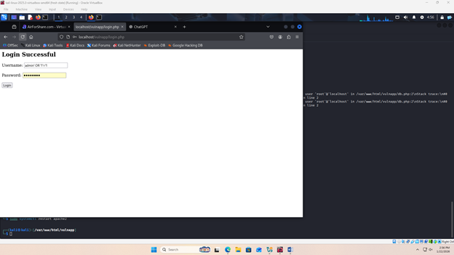
- Cross-Site Scripting (XSS)
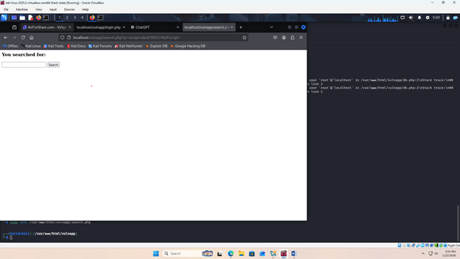
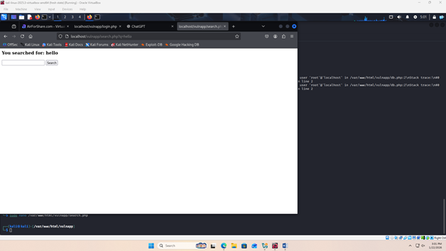
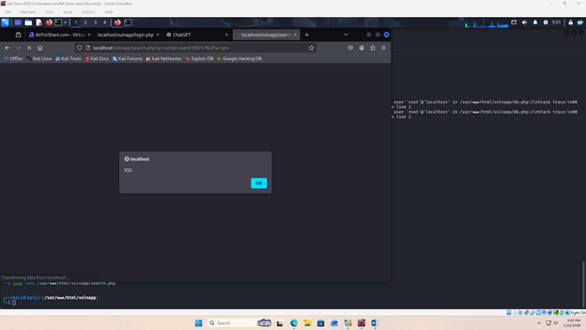
OTHER XSS PAYLOAD
<a href="javascript:alert('XSS')">ClickMe</a>

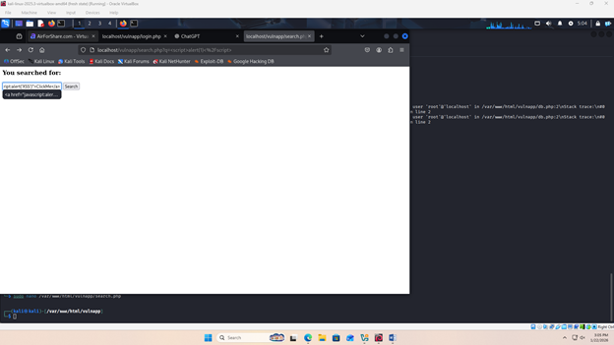
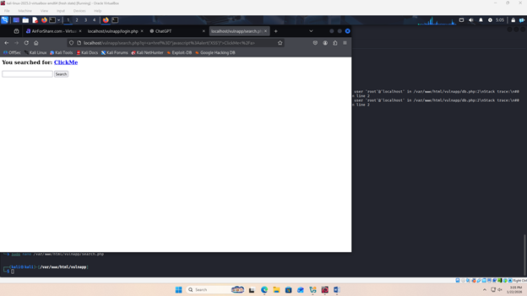
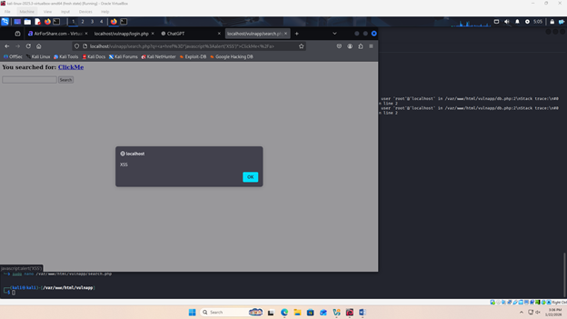

- Remote Code Execution (RCE)
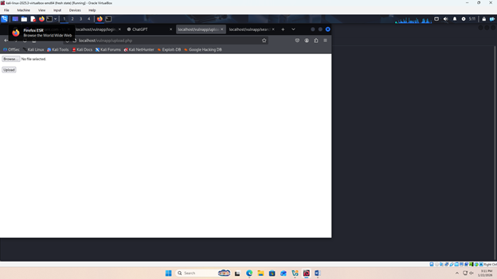
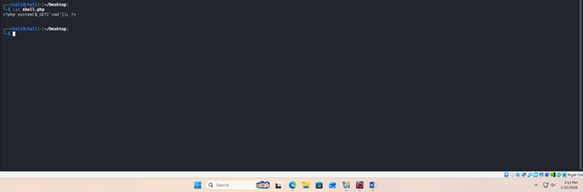
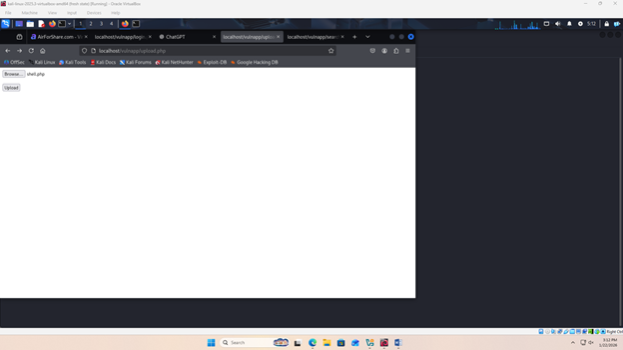
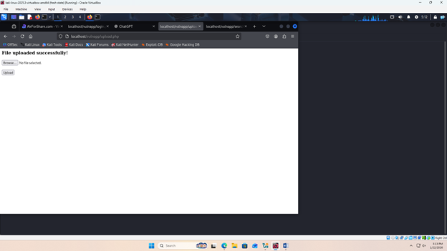
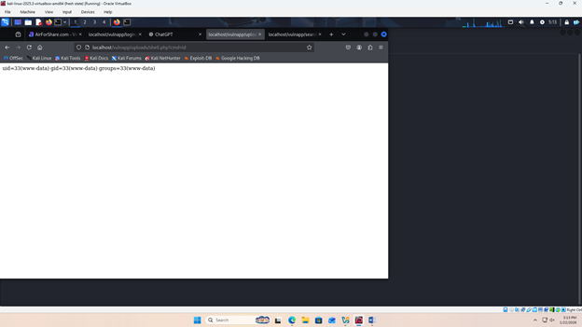
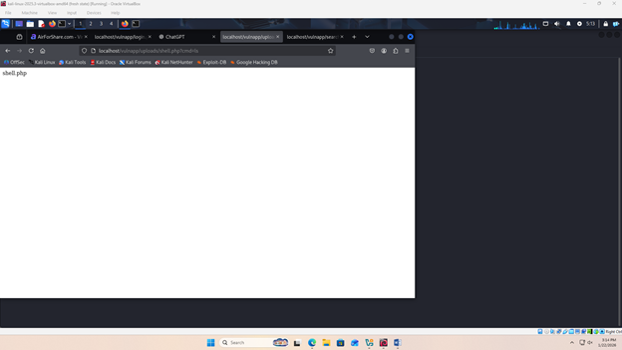
- Broken Access Control
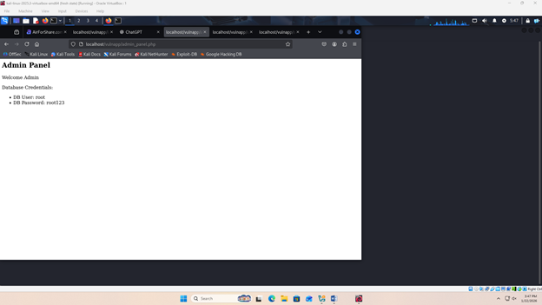
- Command Injection
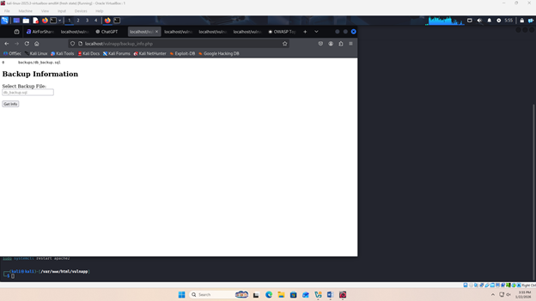
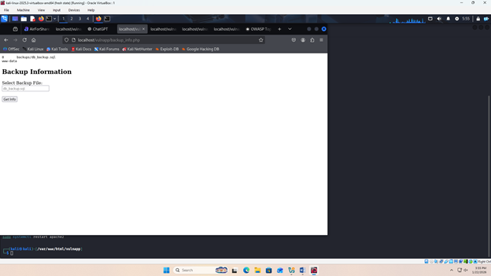
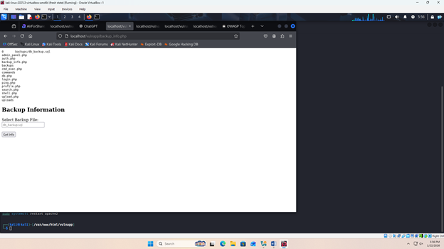

These vulnerabilities were deliberately implemented for educational and testing purposes.

3. Environment Setup
- Operating System: Kali Linux (Testing Machine)
- Web Server: Apache HTTP Server 2.4.65
- Database: MySQL
- Application Language: PHP
- Assessment Tools:
  - Nmap
  - Nikto
The vulnerable application was hosted locally on port 80.

4. Vulnerability Assessment Methodology
The assessment was conducted in three phases:
- Reconnaissance and Port Scanning using Nmap
- Web Server and Application Scanning using Nikto
- Comprehensive Vulnerability Analysis using Nessus

Nmap Scan Results

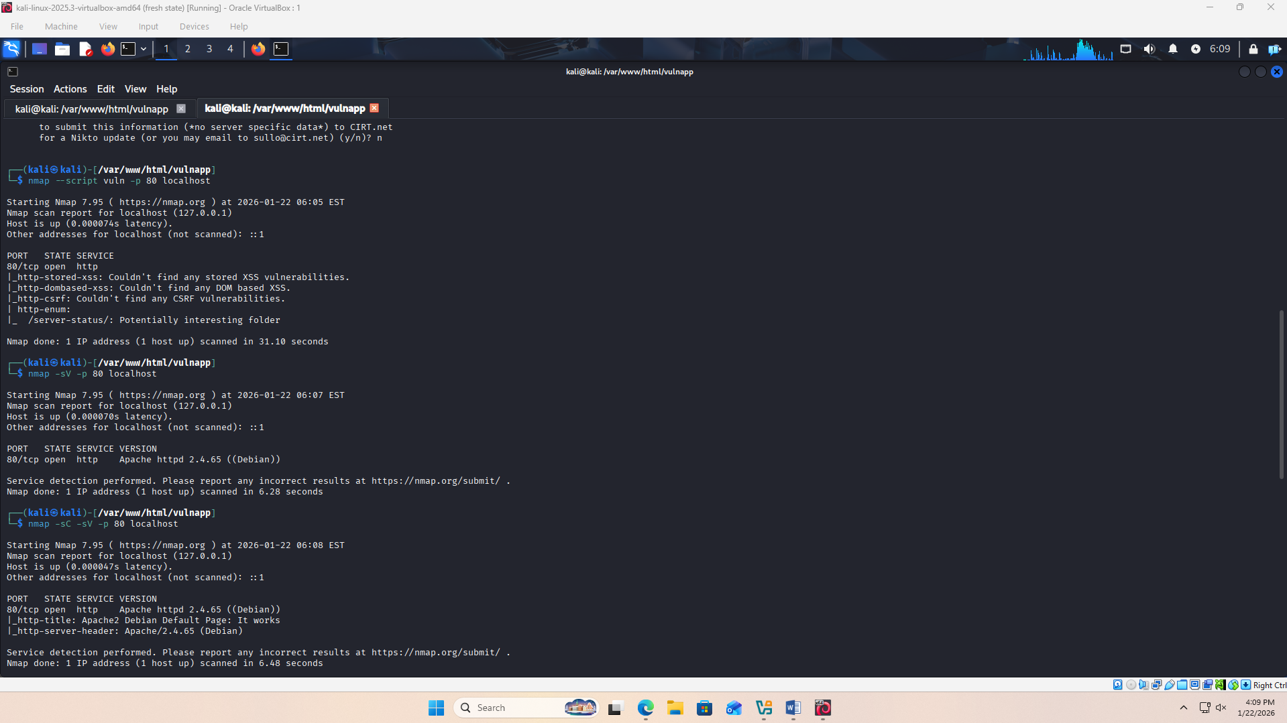

Tool Used
- Nmap (Network Mapper)

Findings
- Port 80/tcp was found open
- Service detected: Apache HTTP Server 2.4.65
- No immediate critical vulnerabilities were detected during this scan

Analysis
Nmap primarily provided reconnaissance information, identifying open ports and the running web service. While Nmap did not directly reveal application-level vulnerabilities, it confirmed the presence of a web server that required further analysis using web-focused tools.

Nikto Scan Results

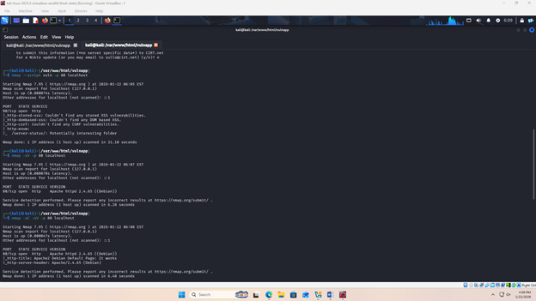

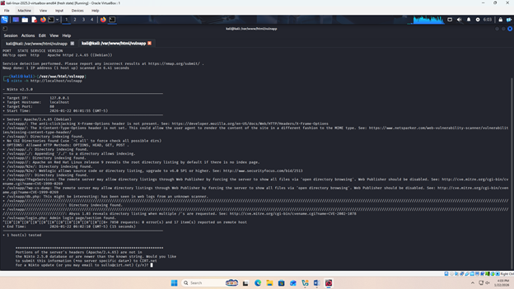

Tool Used
- Nikto Web Vulnerability Scanner

Findings
Nikto identified several critical security misconfigurations:
- Missing HTTP Security Headers:
  - X-Frame-Options
  - X-Content-Type-Options
- Directory Indexing Enabled
- Accessible sensitive files:
  - db.php
  - login.php
- Multiple HTTP methods enabled
- Outdated and misconfigured server settings

Security Impact
- Missing headers expose the application to clickjacking and MIME sniffing attacks
- Directory listing allows attackers to discover sensitive files
- Publicly accessible configuration files lead to information disclosure
- Excess HTTP methods increase the attack surface

Conclusion
Nikto confirmed poor security configuration, which supports and facilitates exploitation of other vulnerabilities such as SQL Injection, RCE, and Broken Access Control.

7. Vulnerability Summary Table
Vulnerability | OWASP Top 10 Category | Severity
SQL Injection | A03: Injection | High
XSS | A07: XSS | Medium
RCE | A03: Injection | Critical
Broken Access Control | A01: Broken Access Control | High
Command Injection | A03: Injection | Critical

8. Remediation and Recommendations

1. SQL Injection
Resolution:
- Use prepared statements and parameterized queries
- Implement input validation and sanitization
- Use least-privilege database accounts

2. Cross-Site Scripting (XSS)
Resolution:
- Encode output using HTML encoding
- Validate and sanitize user inputs
- Implement Content Security Policy (CSP)

3. Remote Code Execution (RCE)
Resolution:
- Restrict file upload types and permissions
- Disable dangerous PHP functions (exec, system, shell_exec)
- Store uploaded files outside the web root

4. Broken Access Control
Resolution:
- Implement proper authentication and authorization checks
- Use role-based access control (RBAC)
- Restrict access to sensitive files and directories

5. Command Injection
Resolution:
- Avoid executing OS commands from user input
- Use safe APIs instead of shell commands
- Sanitize and validate all user inputs

6. Server Misconfigurations
Resolution:
- Disable directory listing
- Add security headers:
  - X-Frame-Options
  - X-Content-Type-Options
- Restrict HTTP methods
- Regularly update server software

9. Conclusion
This lab demonstrated how an intentionally vulnerable application can be assessed using Nmap, Nikto, and Nessus. The assessment successfully identified multiple OWASP Top 10 vulnerabilities, including SQL Injection, XSS, RCE, Broken Access Control, and Command Injection. Proper remediation steps were proposed to mitigate these risks. The exercise highlights the importance of secure coding practices, proper configuration, and regular vulnerability assessments in real-world environments.

